Food Pyramid represents the amount of each type of food for daily consume.
Food Pyramid is divided into fats, meats and dairies, fruits and vegetables, rice and alternatives.
Its important to have a balanced diet to have energy and health.


FATS

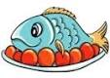
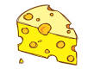
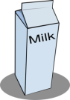
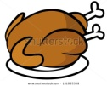
MEATS DAIRIES

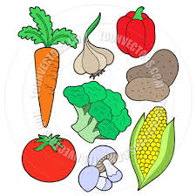
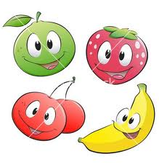
FRUITS DAIRIEVEGETABLES


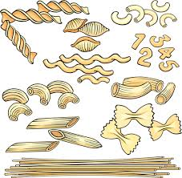
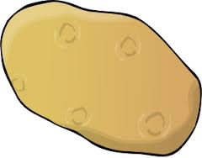
RICE

ALTERNATIVES

